* Switch case more faster than if cause of hashing and in all if need top operate operations
* Try to override static method in interface => we can’t override any static method in classes and interfaces
* Object can't access static method in interface
* 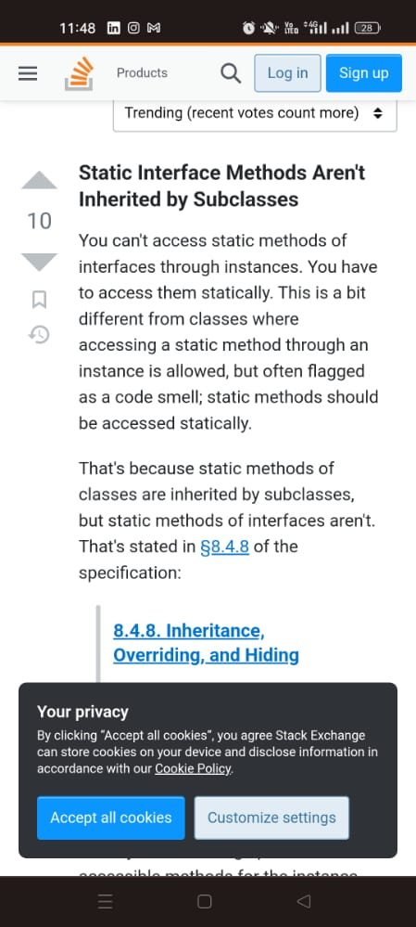
* Difference between hashmap and map and treemap and also set treeset hashset
* 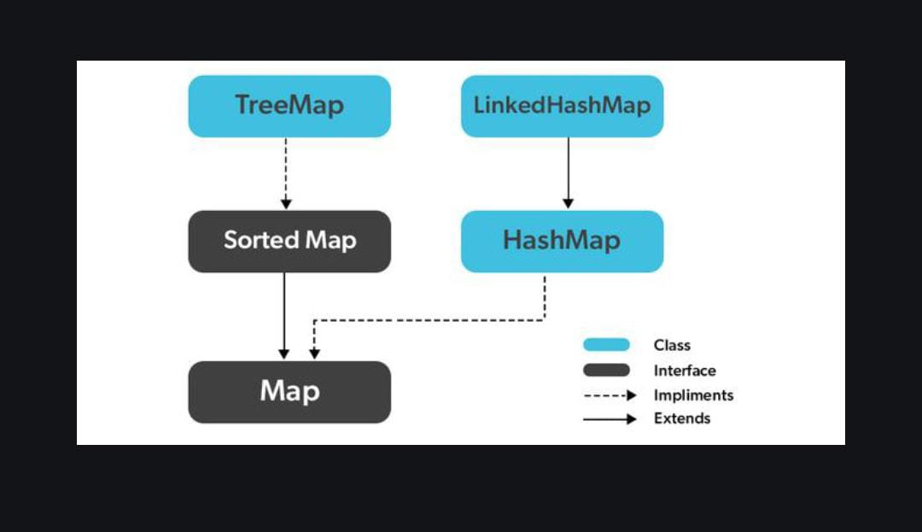
* Can put null as key in hashmap or treemap => can put only one null key in hashmap but treemap doesn’t accept null keys .. all accept multiple nulls in values
* What is annotation is a note for programmer tell compiler to alarm him if write something opposite => like if i wrote @override then if wrote something wrong will cause compiler error but if no annotation then no error normal method not overridden
* System test => search about system test why very cost and we don't do it except customer need it
* Stress test => to CHECK response.. using load balancer “search”
* Why class String is Immutable? to save a lot of heap space be creating a string pool.
* How can we make an Immutable class?
  + Make it final class
  + All data fields must be private.
  + The class doesn't have any setter method.
  + There is no getter method for any reference type data field in the class.
* Why instanceof cause error
* You might think that including so many classes slows down your program execution, but it doesn’t. because this only the path for the class it actually load what used in code
* 
 